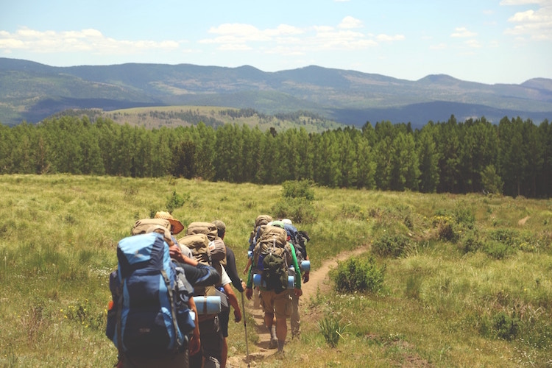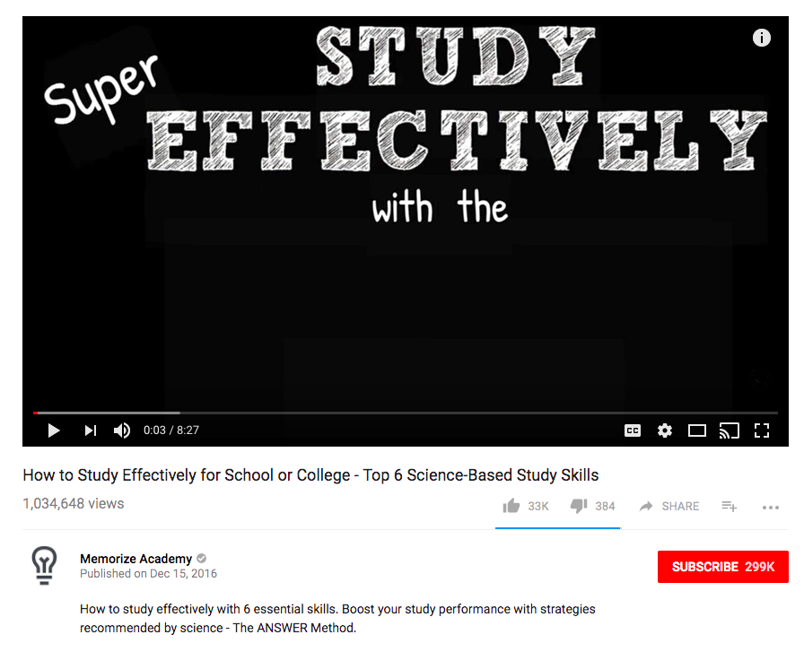

772,251 views

Publication date

A great hike might be the most fun you’ve ever had—if you’re prepared. Samantha Dorfman will get you ready to hike so that you’ll have everything you need for a fun time on the trails.

Author’s screen name

Title

M

hikingisliving

Published on February 10, 2011

Get Ready to Hike

12345

0:00 / 13:35